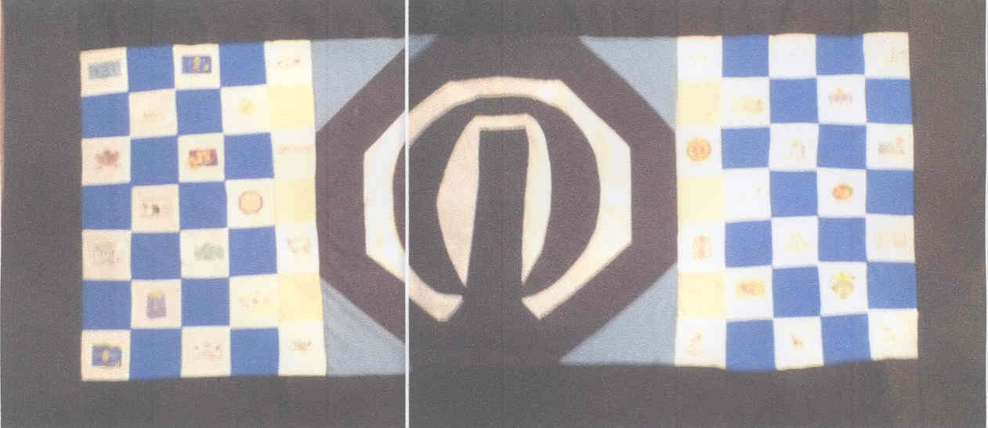
KANSAS LOGO THROW
Ticket Request Form
This request is for:
$5 for 1 $10 for 3 $20 for 7 $40 for 15
$

Check is made to “Optimist International Foundation” and memo states “Kansas CCDHH Scholarship”.
Mail ticket stubs to:

Name

______________________________________________________________________street

______________________________________________________________________City, State, Zip
Mail completed form Charles Mansfield
and your check to: 1101 N Sandplum Ln
Wichita, KS 67212-2936

