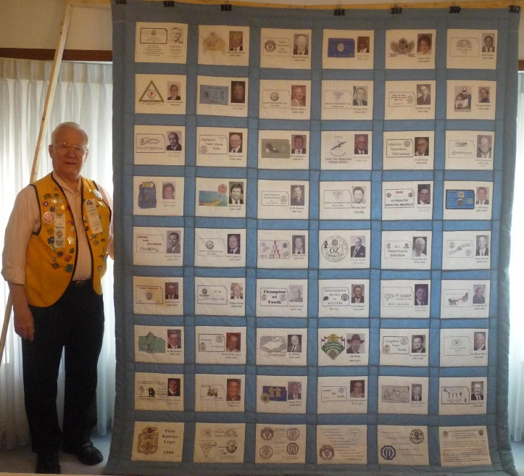

KANSAS
HISTORICAL
QUILT

Ticket Request Form

This request is for:
$10 for 1 $25 for 3 $50 for 7 $100 for 15
$

Check is made to “Optimist International Foundation” and memo states “Kansas CCDHH Scholarship”.
Mail ticket stubs to:

Name

______________________________________________________________________street

______________________________________________________________________City, State, Zip

Mail completed form Charles Mansfield
and your check to: 1101 N Sandplum Ln
Wichita, KS 67212-2936

